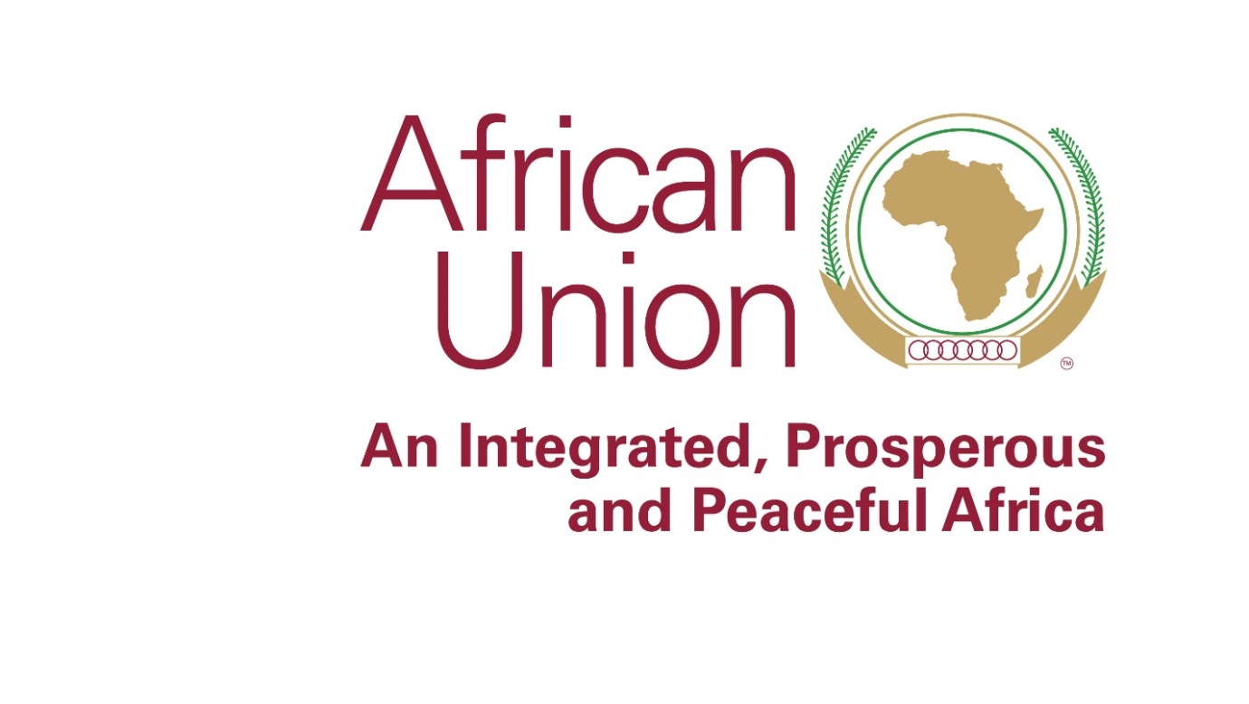

Model African Union 2018
2nd – 4th October, Addis Ababa, Ethiopia
Programme of Work

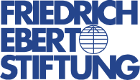

Day 1: Tuesday, 2nd of October
Time | Activity
09:00 – 13:00 | Preperatory meeting:  - Registration of Participants  - Briefing Session on Code of Procedures of a Diplomatic Debate  - Coffee Break  - Briefing Session Continues: Techniques of Making Arguments
13:00 – 14:00 LUNCH BREAK
14:00 - 14:30 | Opening Session:  - Welcome Speech by Dr. Mahama Ouedraogo, Director, AUC HRST  - Welcome address by Erfried Adam, Director, Friedrich Ebert Stiftung AU Cooperation Office
14:30 – 14:45 | Family Photo
14:45 - 15:30 | Launch of the Simulation and Commencement of Committee’s Work
15:30 – 15:45 COFFEE BREAK
15:45 – 17:00 | Continuation of Simulation work
END OF DAY ONE
Day 2: Wednesday, 3rd October
Time | Activity
08:30 – 10:30 | Resumption of simulation work
10:30 - 10:45 COFFEE BREAK
10:45 - 12:30 | Resumption of Simulation Work, Routing of Draft Resolution and Deliberation of the Jury for the Best Delegates
12:30 – 13:30 LUNCH BREAK
13:30 – 15:30 | Resumption of Simulation Work and Vote on Draft Resolution
15:30 – 15:45 COFFEE BREAK
15:45 – 17:00 | Resumption of Simulation Work and Vote Draft Resolution  - Gathering resolution papers from committees and sending to the Executive Council  - Closing the work session of the committees
END OF DAY TWO
Day 3: Thursday, 4th October
Time | Activity
08:30 – 10:30 | Ordinary Session of the Executive Council (Ministers of Foreign Affairs)  - Presentation of the work of Committees and bodies
10:30 – 10:45 COFFEE BREAK
10:45 – 13:00 | Resumption of Work: Ordinary Session of the Executive Council  - Adoption of decisions and transmission of Resolutions to the conference  - Closing of the ordinary session of the Executive Council
13:00 – 14:00 LUNCH
14:00 – 16:00 | Resumption of work: Ordinary Session of the Assembly (Heads of State and Heads of Government)  2018 Theme of the Year: "Winning the fight against corruption, a sustainable path to Africa’s transformation"  - Presentation of the Decisions of the Ordinary Session of the Executive Council  - Open debate, vote and adoption of the Decisions and Declarations of the Ordinary Session of the Assembly
16:00 – 16:30 | Closing session  - Closure of the work of the Ordinary Assembly of the Conference
16:30 – 17:00 | Closing remarks by AUC HRST and presentation of Certificates
END OF SIMULATION

The Executive Council
The Agenda
• Open debate: speeches.
• Adoption of the agenda and organization of work.
• Review of reports / resolutions:
o The Peace and Security Council.
o ECOSOCC
o The African Committee of Experts on the Rights and Welfare of Children.
• Adoption of the decisions of the Ordinary Session of the Executive Council.
• Consideration of the Draft Agenda for the Ordinary Session of the Assembly of the Simulation of the African Union Summit.
• Divers questions.
• Closing of the meeting.

The Assembly
[Combatting corruption, a sustainable path to Africa’s Transformation].
Draft agenda
OFFICIAL OPENING:
• AU anthem.
• Speeches.
PLENARY SESSION:
• Adoption of the agenda and organization of work.
• Topic of the summit: "Combatting corruption, a sustainable path for Africa's transformation":
- Presentation of the Theme by the President of Rwanda.
- Debate.
• Adoption of reports / draft resolutions:
o The Peace and Security Council.
o ECOSOCC
o The African Committee of Experts on the Rights and Welfare of Children.
• Adoption of the decisions of the Ordinary Session of the Assembly.
• Divers questions.
• Closing ceremony.

